ASSIGNMENT -1

|  |  |
| --- | --- |
| NAME | P.GAYATHRII |
| ZONE | 8 |
| COLLEGE | GANESH COLLEGE OF  ENGINEERING |
| TEAM ID | NM2023TMID00964 |

1. Go to the chrome and open remix platform

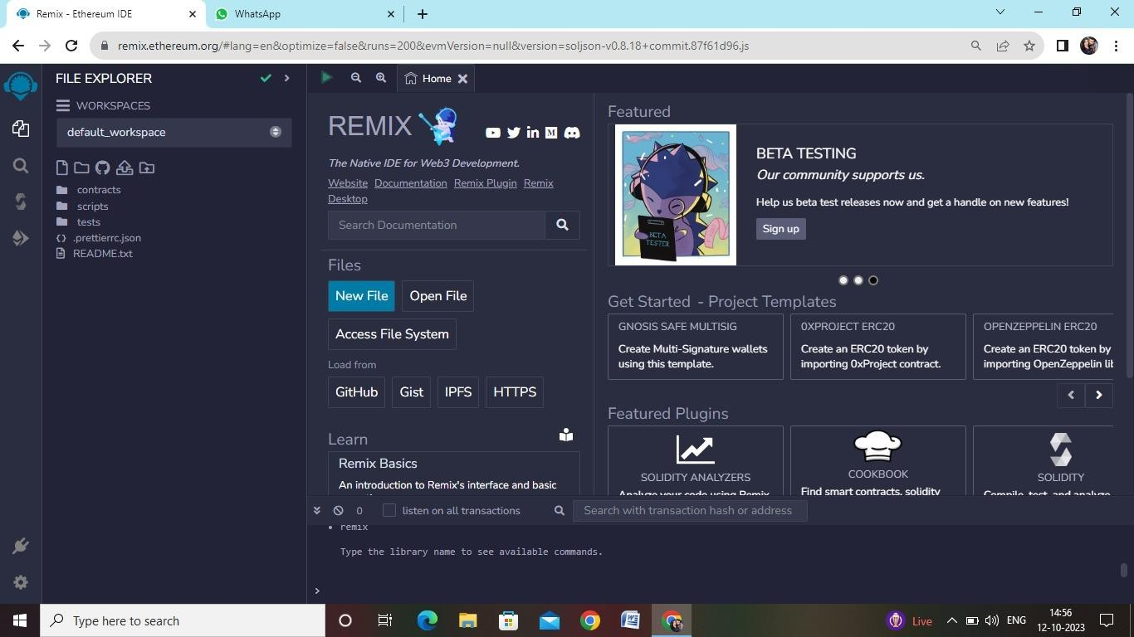

1. Open the remix

page and create a new file

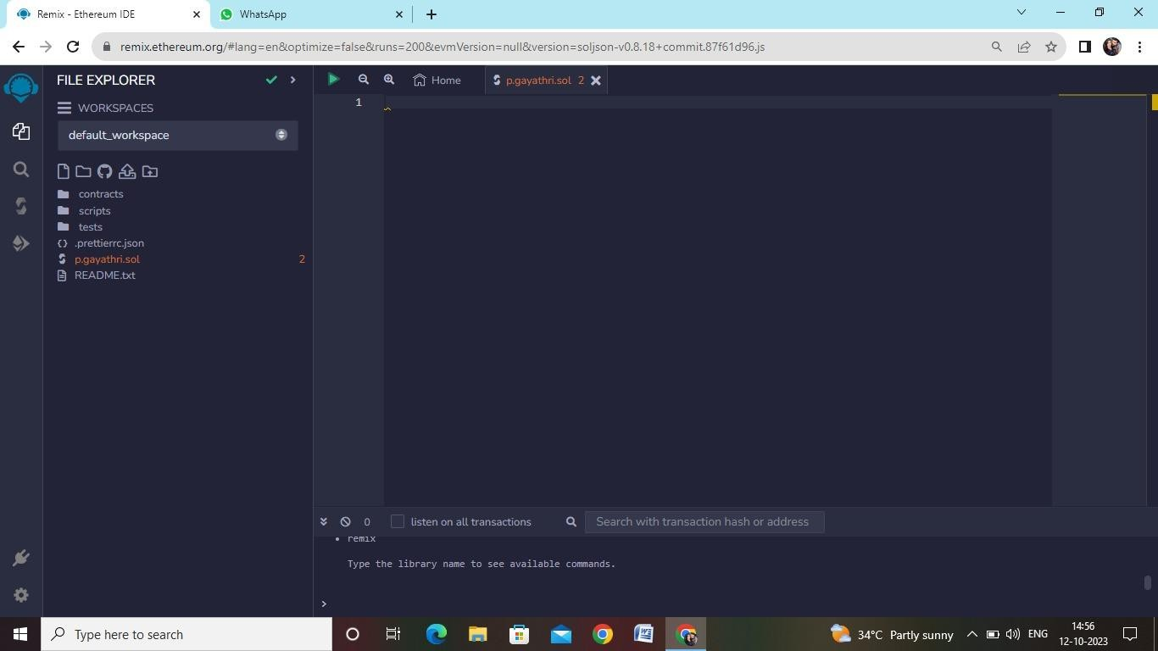

1. In that newly created file, create a program to return your string, "Zone

name"

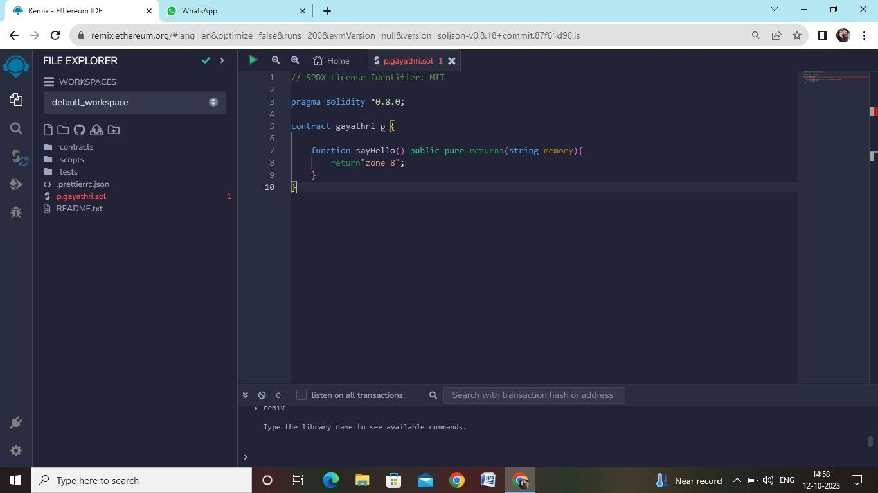

PROGRAM:

// SPDX-License-Identifier: MIT pragma solidity ^0.8.13; contract mycontract

{

function getZoneName() public pure returns (string memory)

{

return "Zone name";

}

}

1. Save the program and compile it to get the ABI and Bytecode

ABI:

[

{

"inputs": [],

"name": "getZoneName", "outputs": [

{

"internalType": "string", "name": "",

"type": "string"

}

],

"stateMutability": "pure", "type": "function"

}

]

BYTECODE:

608060405234801561001057600080fd5b50610173806100206000396000f3fe6080604052348015

61001057600080fd5b506004361061002b5760003560e01c8063235ed70f14610030575b600080fd5

b61003861004e565b604051610045919061011b565b60405180910390f35b606060405180604001

b60005b838110156100c55780820151818401526020810190506100aa565b600084840152505050 50565b6000601f19601f8301169050919050565b60006100ed8261008b565b6100f7818561009656

5b93506101078185602086016100a7565b610110816100d1565b840191505092915050565b60006

02082019050818103600083015261013581846100e2565b90509291505056fea264697066735822

00000000815250905090565b600081519050919050565b600082825260208201905092915050565

60405280600981526020017f5a6f6e65206e616d6500000000000000000000000000000000000000

1. 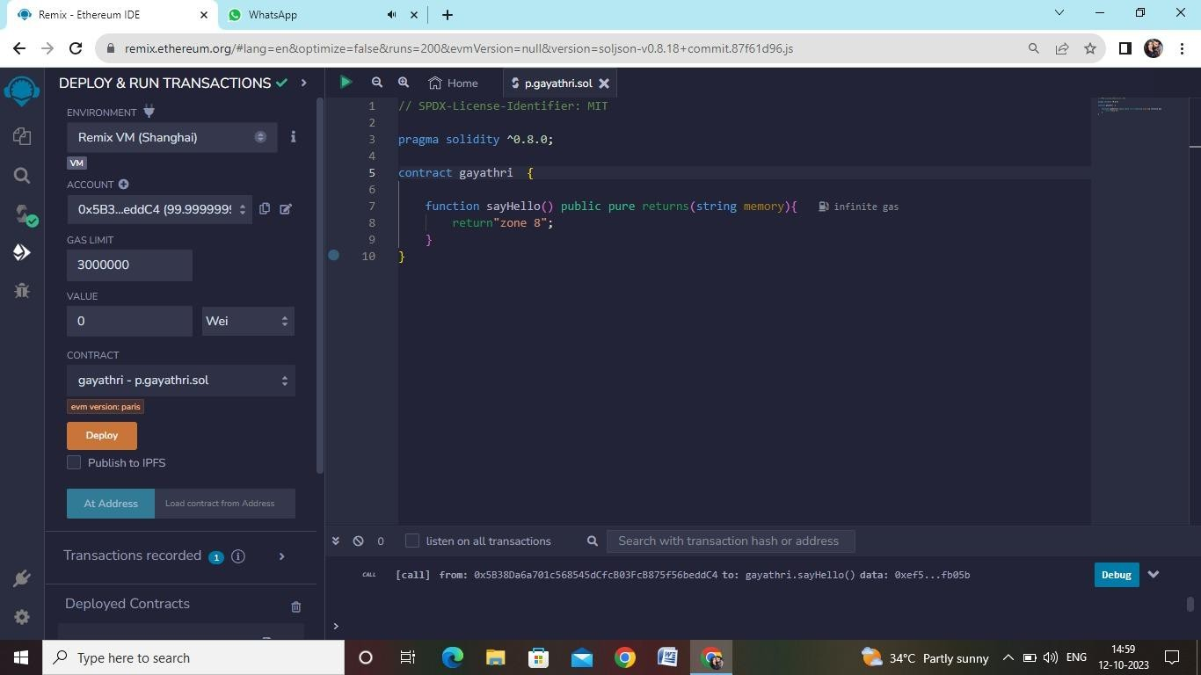Finally Deploy it to display the output

8120033

1220de928d37c2ccf4326108d8d4ce3e44d787cfd0b8ee72b632f0e5d1f9bb28622a64736f6c6343000